# **CHAPTER FIVE**

# **RESEARCH FINDINGS AND ANALYSIS**

## 5.1 Response rate

The response rate is determined by dividing the number of people who completed the questionnaire by the number of people in the study sample. In this research study, online questionnaires were administered to 15 participants, and 12 people successfully completed the analysis. This response rate is 80% due to the limitations of time.

## 5.2 Demographics results

### 5.2.1 Distribution by Age

The responses were majorly distribute among the young persons. Majority of the respondents were between 19 - 24 years (63.6%), 25 – 29 years (22.7%), 30 – 35 years (9.1%) and over 35 years (3.9%). This shows that individuals from different age groups are interested in the idea of having an online GBV campaign and awareness system. The age distribution is a clear indication that the participants most probably have a good understanding of the project topic.

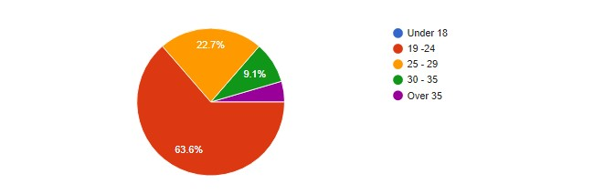

*Figure 5.1: Questionnaire Response Age Distribution*

*Source: Author data 2021*

### 5.2.2 Distribution by Gender

The study’s results indicated that 58% of the respondents in the survey were female whereas 41.7% male. This indicates an almost even distribution of participants along gender lines, which is an important factor to consider for validating the responses. The pie chart below depicts the gender distribution of the respondents.

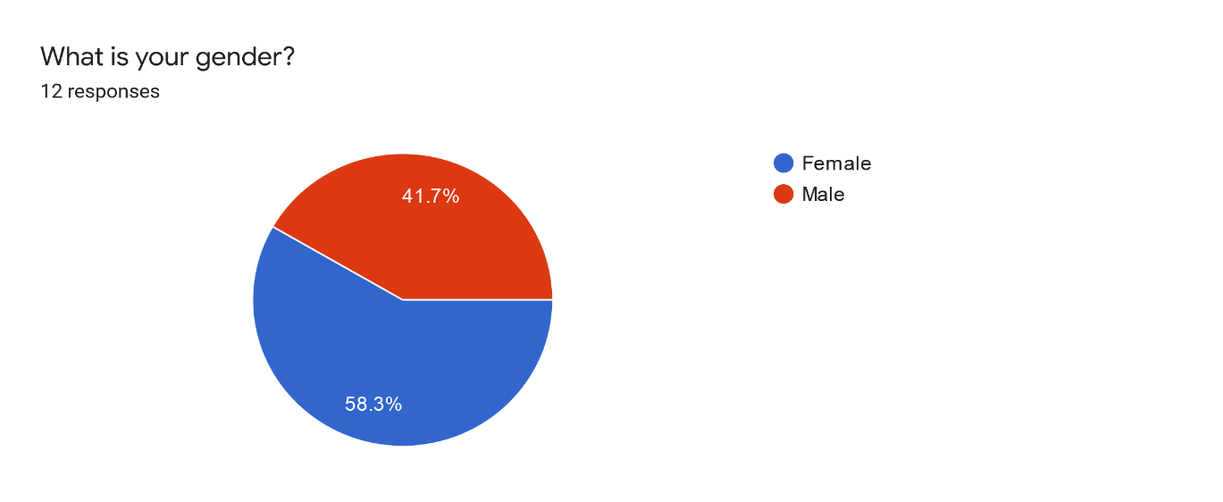

*Figure 5.2: Questionnaire Response Gender Distribution*

*Source: Author data 2021*

### 5.2.3 Distribution by Locality of Residents

The survey revealed that 66.7% of the respondents lived in an urban setting, 25%% in semi urban settings whereas 8.3% lived in a rural setting. This data is relevant in determining the likelihood of the respondents having experienced any acts of gender-based violence and to what extent.

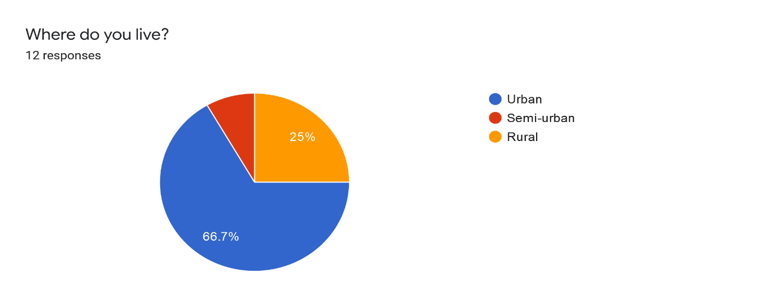

*Figure 5.3: Distribution by Locality of Residence*

*Source: Author data 2021*

## 5.3 Results on the Challenges of existing GBV Campaign and Awareness systems

Respondents were asked to select the obstacles that they primarily relate to when employing preexisting GBV campaign and awareness systems based on the study's research objectives. 33.3% of the respondents felt that complicated and complex user interfaces is a major challenge to them. 83.3% had challenges with the lack of safe and secure spaces for reporting GBV cases. 58.3% felt that limited sources of information that address issues related to gender-based violence is a challenge with the existing systems. 58.3% had problems with inaccurate and inconsistent information and data about gender-based violence. 50% felt that the existing systems do not protect their privacy and confidential information. 16.7% felt that it is expensive to access information using the existing systems. The majority of the respondents had challenges with the existing systems because they do not provide real-time communication with help providers.

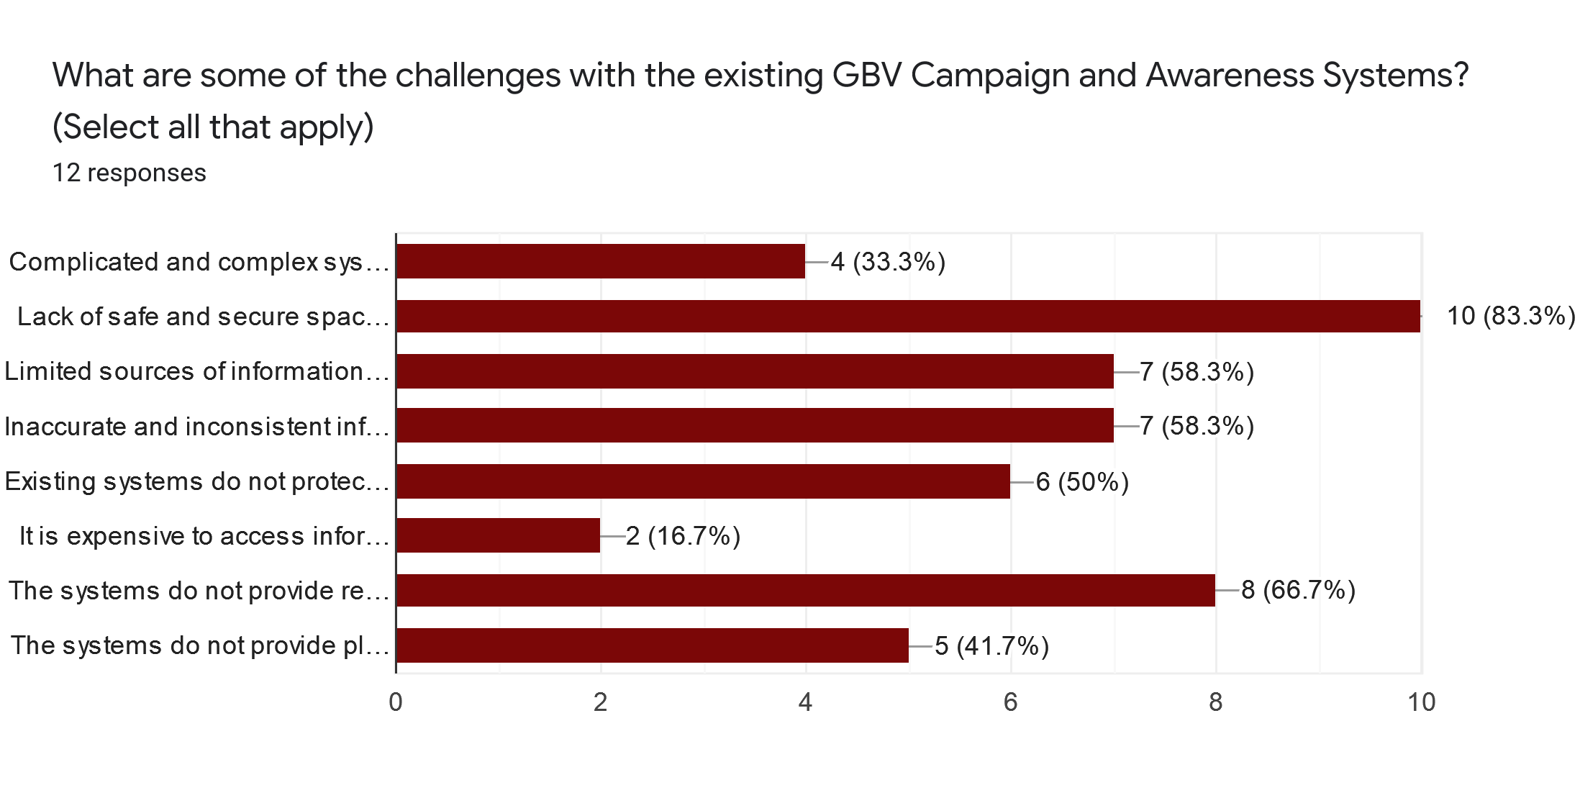

*Figure 5.4: Questionnaire Response on the Challenges of existing GBV Campaign and Awareness systems.*

*Source: Author data 2021*

## 5.4 Results on the Benefits of the Online GBV Campaign and Awareness System.

Respondents were further asked to identify the advantages of the proposed system that they believe will be included in the final product. The most expected benefit according to the respondents is the provision of a safe space where GBV victims can report any act of GBV violence, 83.3%. 68.7% of the respondents expected the system to provide accurate information about GBV, provide real-time communication with counselors and other help providers and improve the protection of user’s private and confidential information. The least expected benefits is low cost of accessing GBV information, 25%.

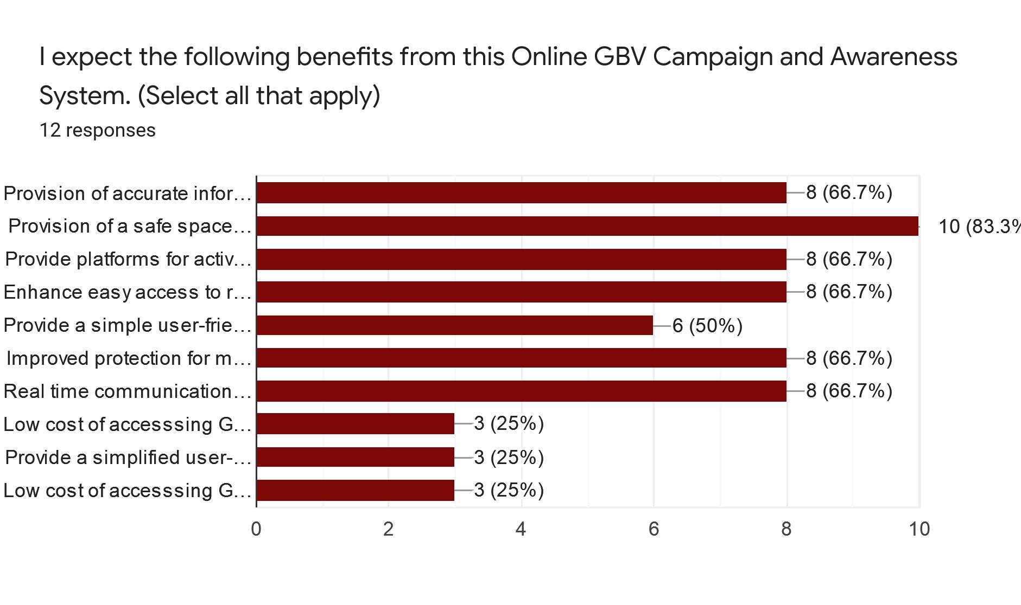

*Figure 5.5: Questionnaire Response on the Benefits of Online GBV Campaign and Awareness systems.*

*Source: Author data 2021*

## 5.5 Viability of the Online GBV Campaign and Awareness System

Respondents were asked if they would recommend the implementation of the proposed system in Nairobi County and 91.7% of them agreed thus giving potential viability to my project.

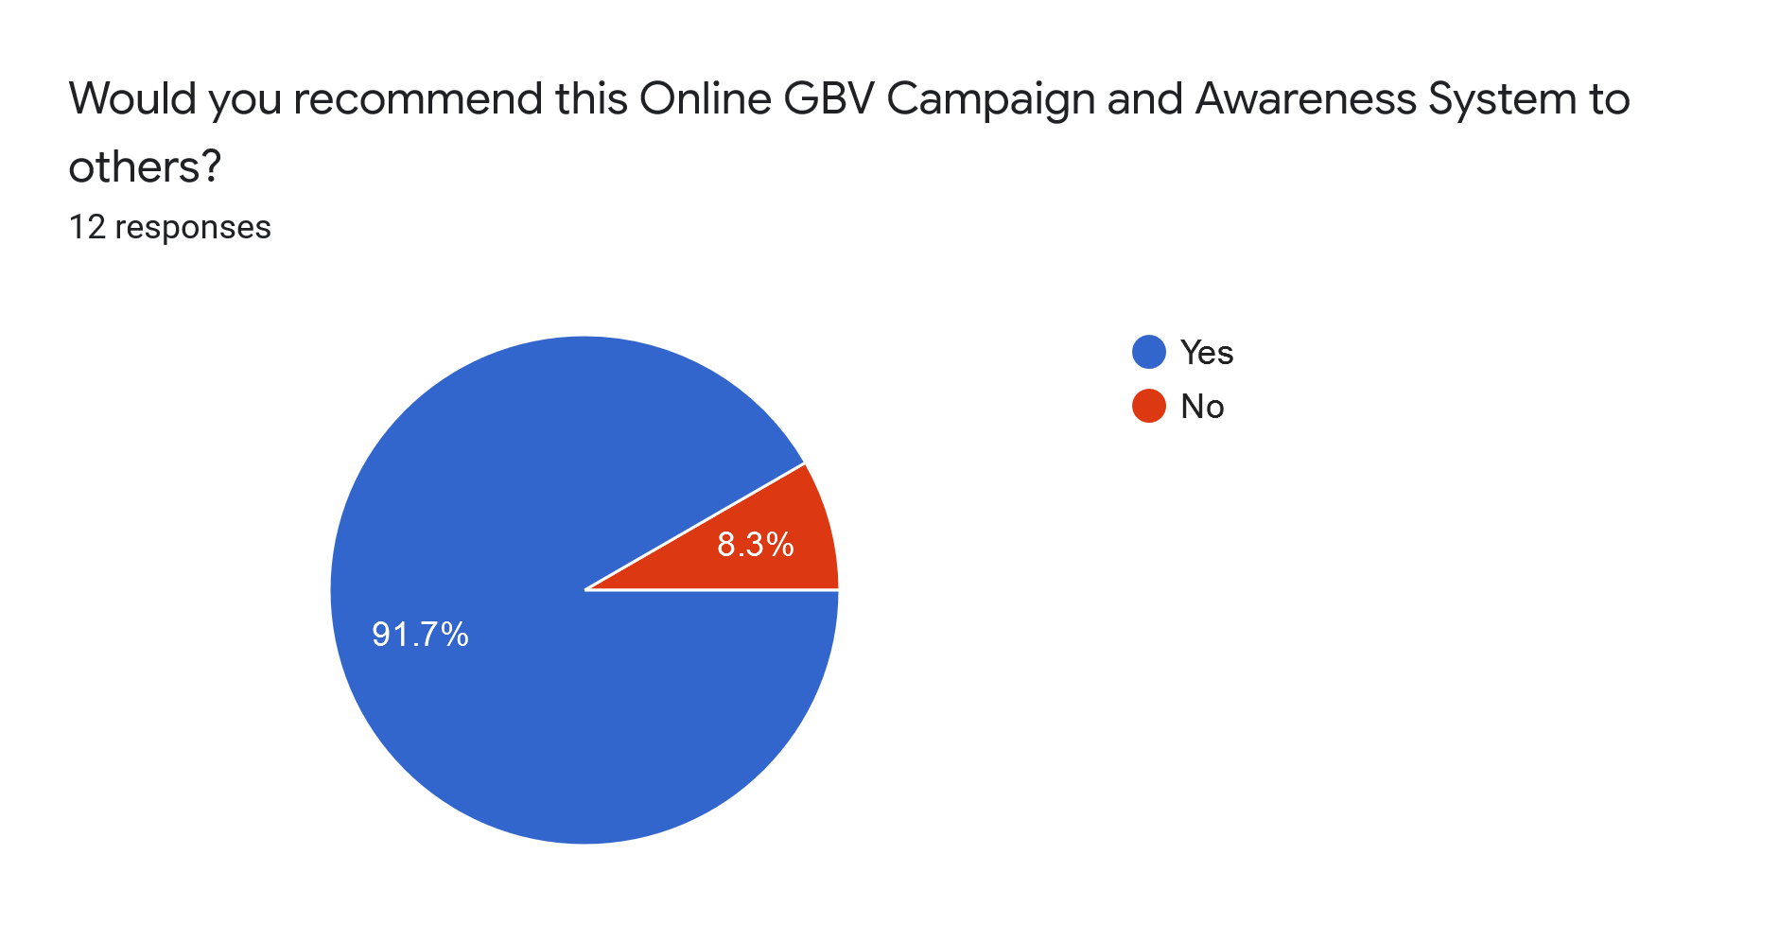

*Figure 5.6: Questionnaire Response on Recommendation/Acceptance of the System*

*Source: Author data 2021*

# **CHAPTER SIX**

# **DISCUSSION, CONCULSION AND RECOMMENDATIONS**

## 6.1 Discussion

The purpose of the research study on Online GBV Campaign and Awareness was to gather data on the feasibility of the proposed system and the challenges of working with existing GBV Campaign and Awareness in relation to the research objectives. We may infer from the 80 percent participation ratio that Gender-Based Violence is a matter that individuals relate to and are open to discussing, and according to the demographic statistics, both men and women are comparably engaged in the topic. The target participants were primarily young people aged 19 to 29 years old. At around this age bracket, it is reasonable to expect these individuals understand the causes, effects and types of gender-based violence and its implications, putting the young people in a position to participate constructively to the GBV topic.

Most of the respondents identified several challenges with the existing systems including; lack of safe and secure spaces for reporting GBV cases, limited sources of information that address issues related to gender-based violence and no provisions for real-time communication with help providers. These are legitimate impediments to the adoption of existing GBV campaign and awareness systems. These findings support the need for an Online GBV Campaign and Awareness System to assist in resolving the issues associated with gender-based violence.

Moreover, participants accentuated the advantages they anticipated and expected from the proposed system to fully identify the system's significance and feasibility. The ones that are most anticipated are: provision of accurate information about gender-based violence, provision of a safe space where GBV victims can report any acts of GBV violence, real-time communication with counselors and other help providers as well as an improved protection for user’s private and confidential information. More individuals would be able to use the system if the participants' expectations are implemented into the final system. This, together with the finding that 91.7% of respondents stated they would advocate the system's adoption, suggests that it has a good chance of succeeding.

## 6.2 Conclusion

The study concludes that integrating GBV victims and other stakeholders with technical assistance can be a prudent plan in the fight against gender-based violence, enhance access to accurate and consistent information to raise awareness, provide help to victims as well as provide safe spaces for reporting GBV cases. This Online GBV Campaign and Awareness System is proposed to address the issues that are typically encountered when using existing GBV campaign and awareness systems, as the web-based system meets the respondents' expectations. As a result, it is a project with possibility, marketability, and feasibility.

## 6.3 Recommendations

There is a need to raise public understanding about GBV, including its various forms, causes, and proper solutions. The Department of Gender and Social Development can take the lead by using the internet (e.g. websites) and media advertisements to raise awareness. As a strategy for increasing GBV awareness among the general public, the Department may explore identifying and collaborating with NGOs working in the field of GBV in Nairobi County.

Various stakeholders must implement programs targeted at increasing GBV reporting to appropriate authorities and assisting in providing help to the GBV victims. This can be done by creating safe spaces and encouraging victims to speak up and find assistance.

## 6.4 Future work

The current proposed system is targeted at the stakeholders in Nairobi County. Future work would be focused on broadening the system's breadth and catering to other stakeholders in numerous counties, or ambitiously the entire country.

Future research should be conducted to ascertain quality of information for GBV stakeholders in the country in terms of content, accuracy, appropriate format and the currency of the gender-based related information.

Similarly, the future work would include the introduction of privacy policies. The framework would need to be maintained on a regular basis, and protection should be modified if vulnerabilities are discovered, as user data are very critical.

Future work could also necessitate the incorporation of numerous features and functionalities in order for the system to provide its full capability to a larger number of users concurrently.

# **CHAPTER SEVEN**

# **IMPLEMENTATION (PROTOTYPE FRAMEWORK)**

## 7.1 System Implementation

System implementation is the process of defining how the system should be built, ensuring that the system is operational and the system meets quality standards. It involves designing both the frontend and the backend of the system. Frontend focuses on the design and the appearance of the website while backend focuses on the entire application of the system such as in storing and accessing information and details within the database.

## 7.2 Technologies Used

In the development of the Online GBV Campaign and Awareness System, several technologies were used to ensure the effectiveness of the system. The technologies are categorized into; hardware platform, software platform, programming language, programming integrated development environment (IDE) and framework.

### 7.2.1 Hardware Platform.

The machine used for the development is a TOSHIBA Satellite laptop, with a core i3, 2.20GHz processor, 6GB RAM, 64-bit operating system of Windows 10 was used.

### 7.2.2 Programming Language

In the implementation phase, the programming languages used are HTML, CSS, PHP and JavaScript. HTML and JavaScript were used to design the interface; PHP was used at the backend development process, while CSS was used to format the website’s appearance to enhance its attractiveness when the user interacts with the system.

Justification for using PHP.

PHP (Hypertext Processor) was chosen in the development of the backend of the system because of the following reasons: PHP is a server scripting language, and a powerful tool for making dynamic and interactive Web pages. PHP is a widely used, open source and it is compatible with almost all servers. PHP can encrypt data, it supports a wide range of databases, can modify data in the database and it is easy to learn and run efficiently on the server side.

### 7.2.3 Programming Tools

Programming IDE

An IDE is a basic software that consolidates the basic tools needed for software testing and writing. It provides many features for modifying, compiling, deploying and debugging programs. The IDE chosen for this project was Notepad++, which is considered one of the best IDEs for web development and it is an open source code editor. It focuses on features to help the developer be as productive as possible without cluttering up the user interface. It supports languages such as HTML, CSS, PHP and JavaScript.

Programming Framework.

A framework is an abstract or concrete supporting idea under which software providing generic functionality can be selectively changed by additional user-written code, thus providing application-specific functionality. The framework used in this project is **Bootstrap**, which is the most popular HTML, CSS and JavaScript framework for developing responsive, mobile–first websites.

### 7.2.4 Software Platform

**XAMPP**

Xampp is a free and open-source cross-platform web server solution stack package consisting mainly of the Apache HTTP Server and interprets for scripts written in PHP. Xampp is a simple and lightweight package used to create a local web server for PHP development and testing.

**MySQL Database**

MySQL is the world’s most popular open-source relational database management system. Its primary use is for online storing and logging applications. MySQL database was used on the backend because it provides maximum scalability and high capacity to store many details concerning the system users and the admin of the system.

**Apache HTTP server.**

Apache server, which is the most popular open-source, cross-platform web server, was used because it is free, it is easy to use yet powerful and it can run perfectly on any of the OS (Linux, windows and mac OS). This software powers the website and allows it to run on the internet web browsers.

**Microsoft Office**

* For documentation and writing of the report, Microsoft Word was used.
* For planning and scheduling the project milestones, Microsoft Project 2016 was used.
* Microsoft Excel was used for tables exported from the database
* Microsoft PowerPoint was used for presentation

**Google Forms**

Google forms was used in the formulation and analysis breakdown of the online questionnaire and survey, especially when conducting the research study.

**Draw.io**

This is a free and open online diagram software. It was used for the graphical representations

## 7.3 Features of the Prototype

The following are the features of the prototype:

* The system allows users to register and/or log in
* The system will allows victims to report cases, book appointments and get help.
* The system will allows volunteers to view cases reported.
* The system will allows victims and volunteers to donate, view and write blogs.
* The system will save all uploaded data to the database.
* The system will be able to display all the uploaded data.
* The system only gives access to authorized users
* The admin will add new users, update and delete user accounts.
* The admin will assign cases and tasks to volunteers.
* The admin, victim and volunteers will be able to export files from the system.
* The admin, victim and volunteers will be able to sign out of the system.

### 7.3.1 Technical Manual Screenshots

### 7.3.2 User Manual Screenshots: - main activity step by step

Volunteer, victim and admin registration pages. Users must create their accounts to access the system

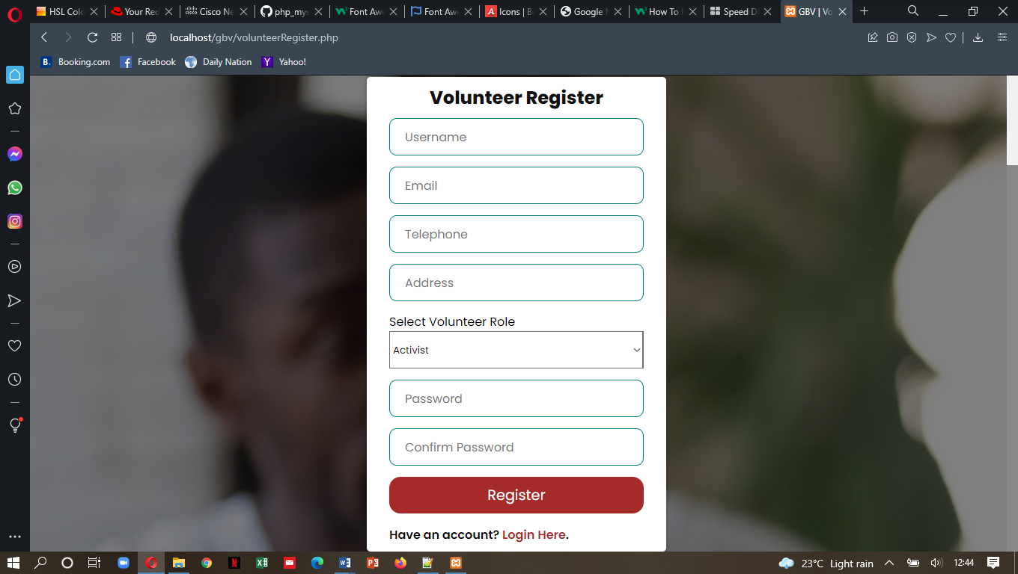 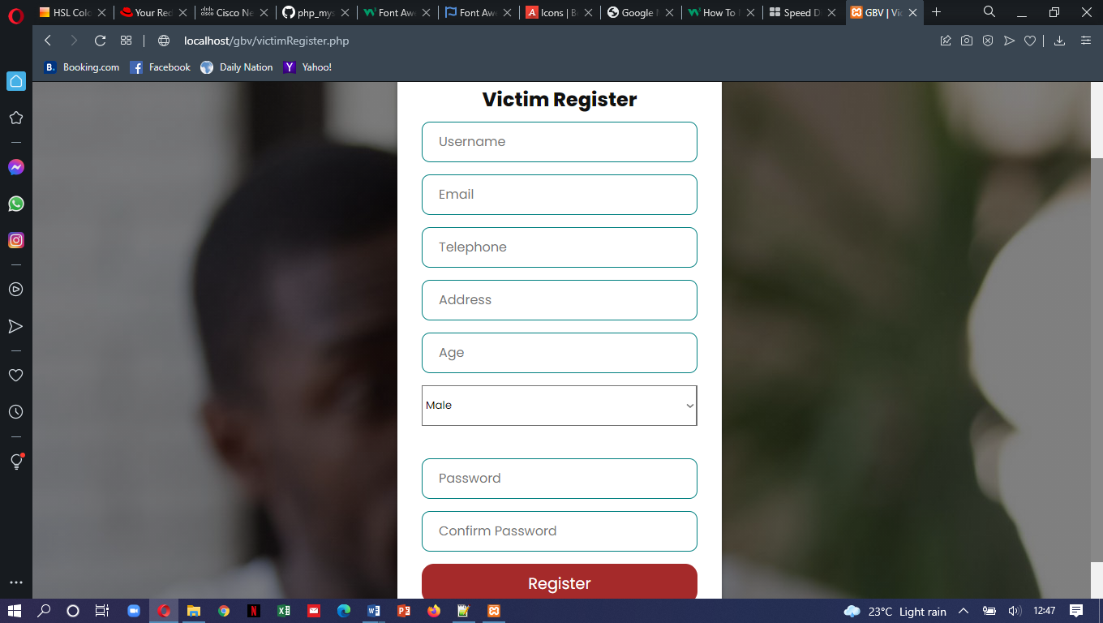 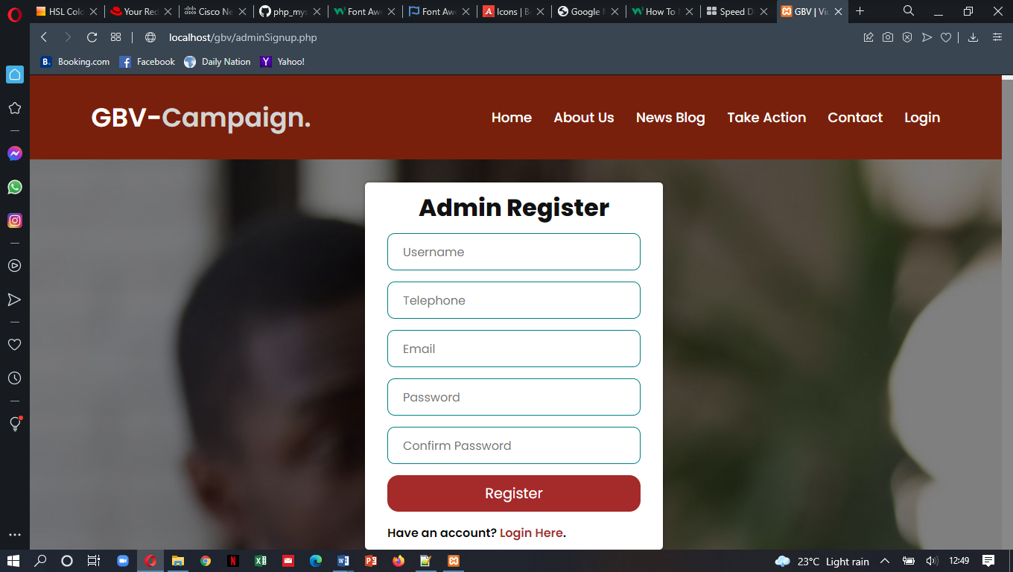

*Figure 7.1: Volunteer, Victim and Admin Signup pages*

Once users have registered, they have to log in to their accounts.

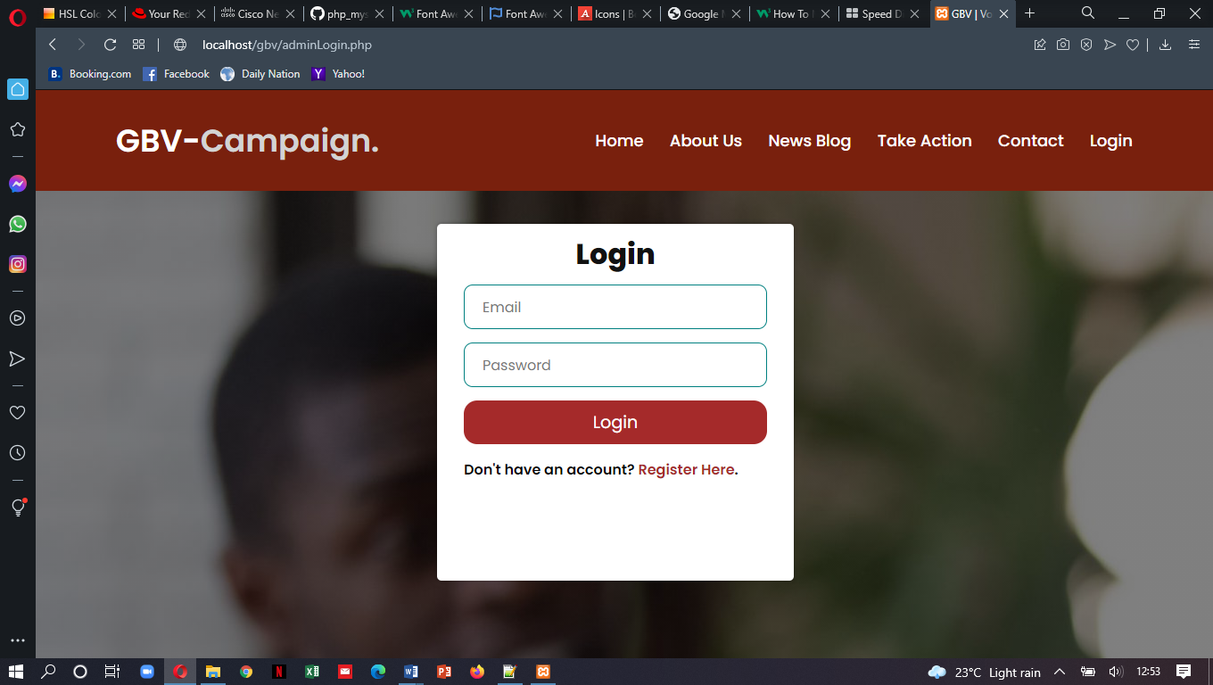

*Figure 7.2: Log in interface*

When victims login, they will be directed to the Victim’s panel

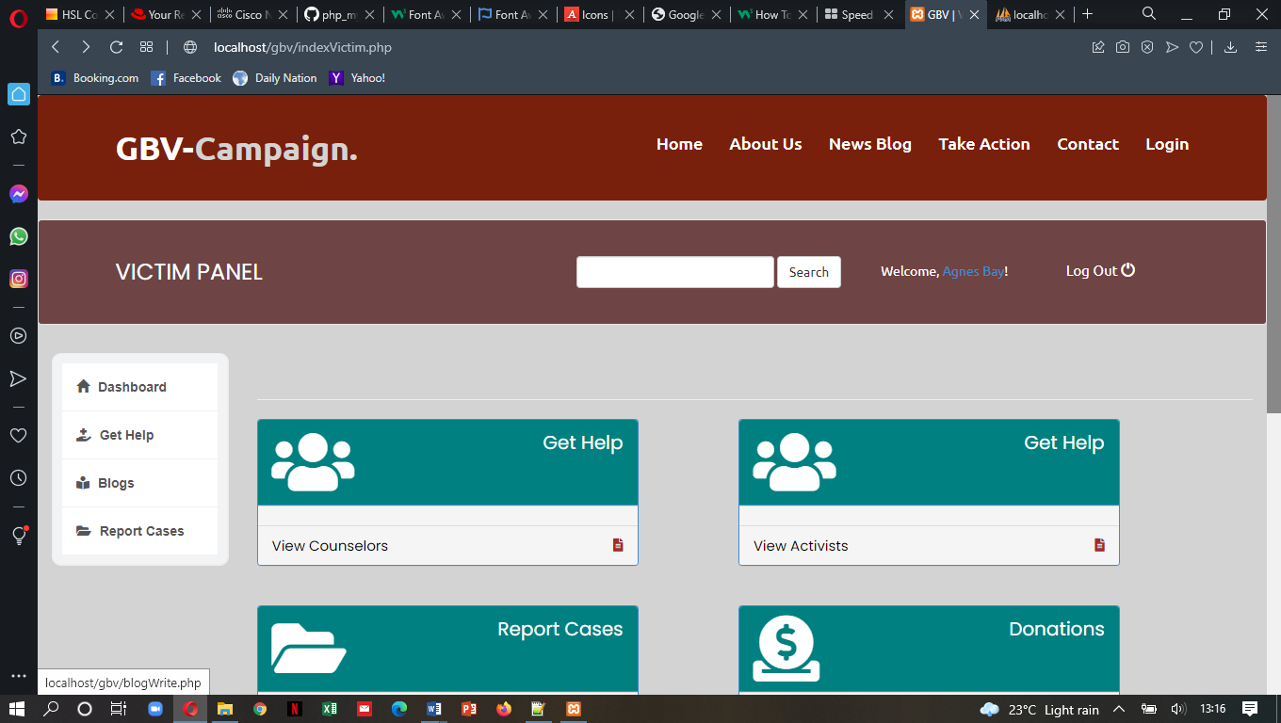

*Figure 7.3: Victim’s Panel Interface*

The victims can get help by filter searching and viewing the available counselors/activists.

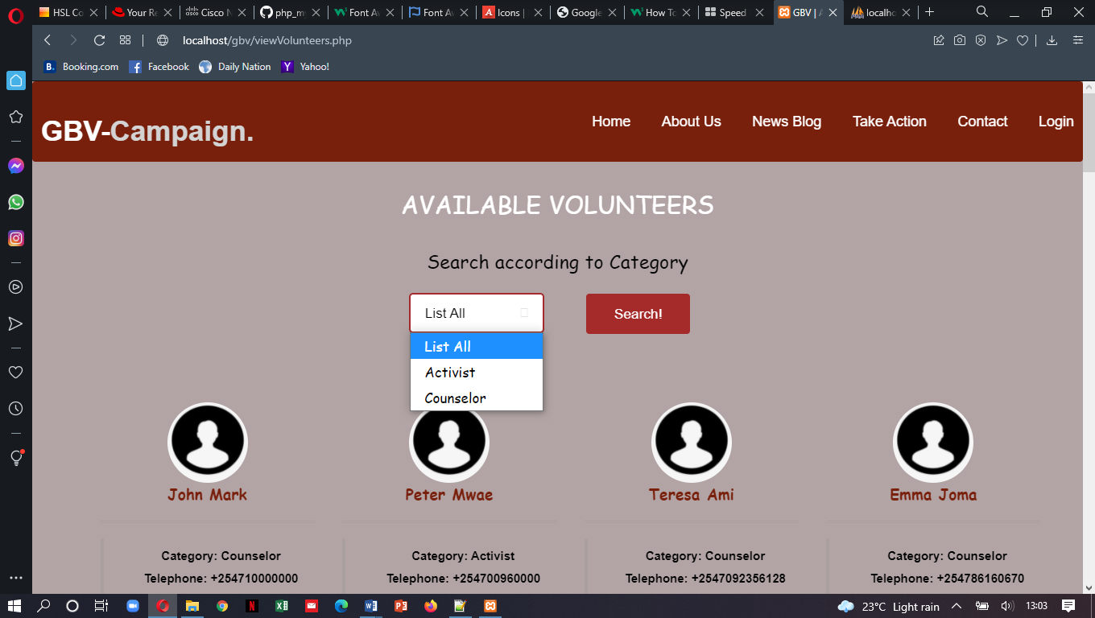

*Figure 7.4: Volunteer Search Interface*

The available volunteers are listed for easy identification using the location categories so that victims can seek help from volunteers near them. The names, categories, telephones and emails of the volunteers is also given to facilitate faster communications.

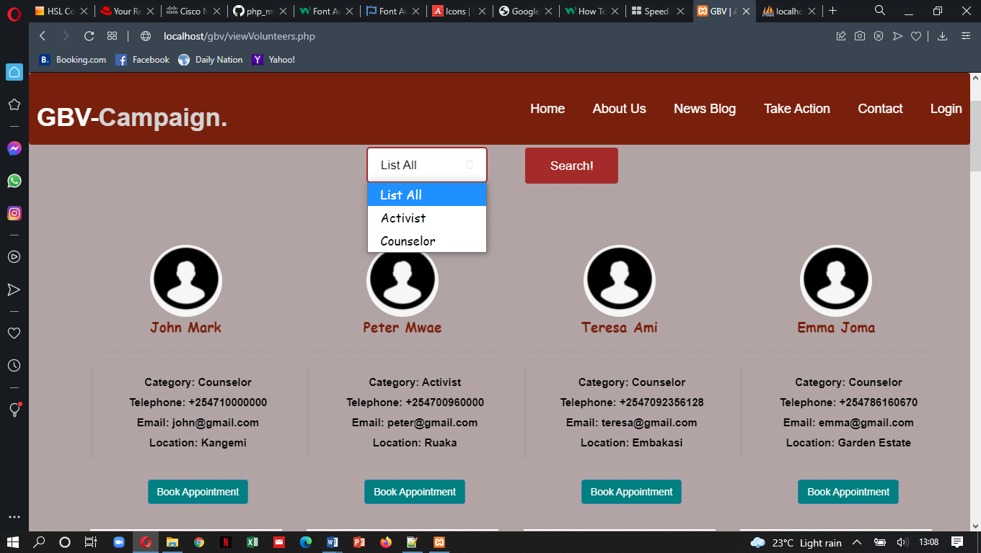

*Figure 7.5: List of available counselors or volunteers interface*

The victims can book appointments with their desired counselor/activist by providing basic information, setting their date and time as well as identifying what kind of help.

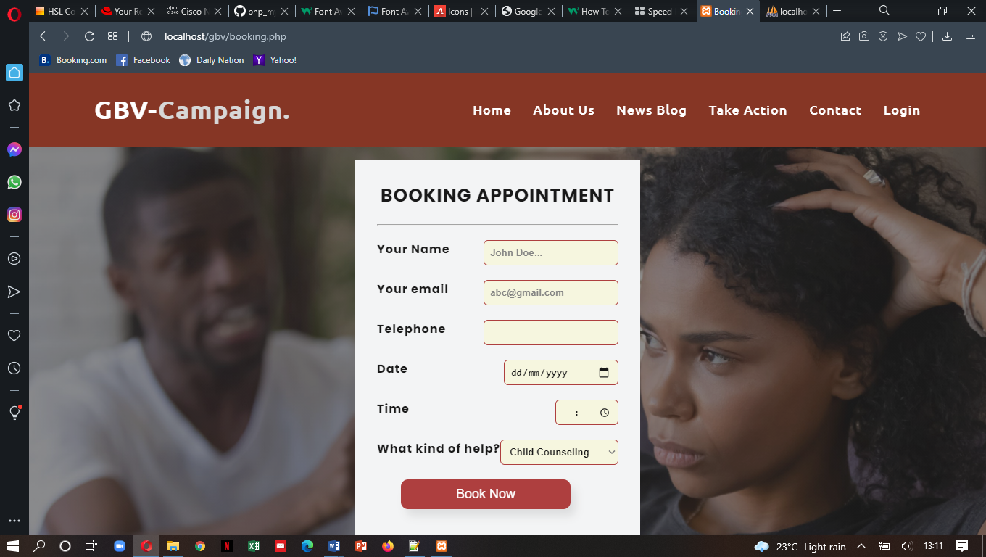

*Figure 7.6: Booking appointment form interface*

After successful booking, the victims can view their appointments

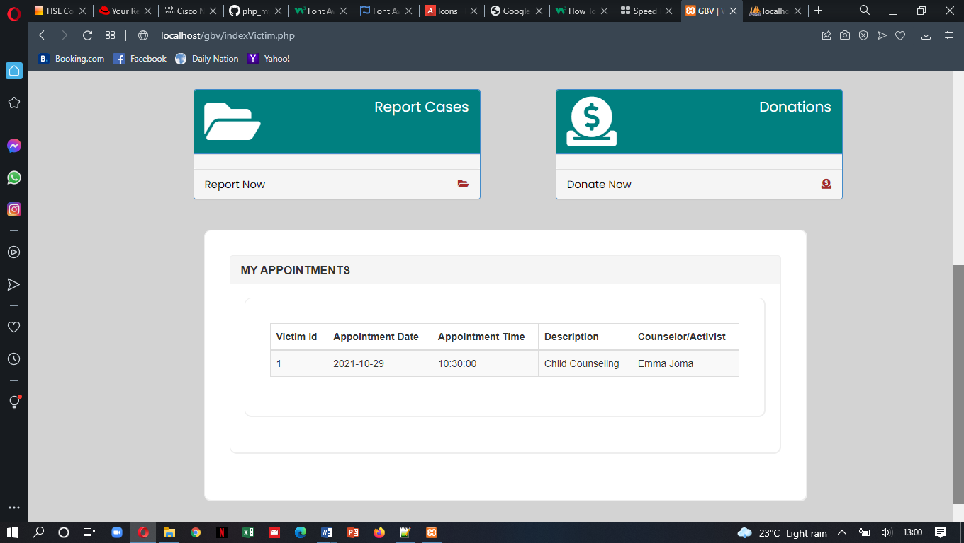

*Figure 7.7: Booked appointment report interface*

Victims or other users can also report GBV related cases

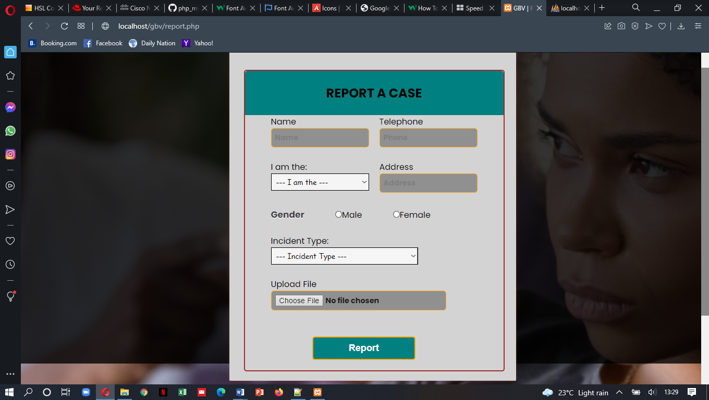

*Figure 7.8: Reporting GBV related cases interface*

If a user logs in as a volunteer, they are directed to the volunteer’s panel. Volunteers can view all their tasks from the dashboard.

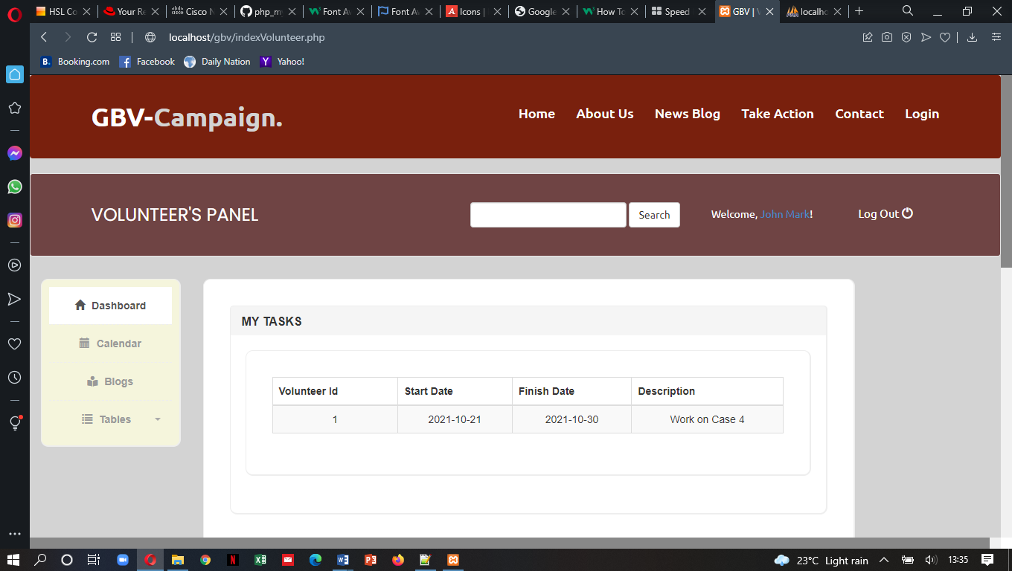

*Figure 7.9: Volunteer’s Panel Interface*

The volunteers have to regularly update the admin about their progress and achievements by reporting using the progress dashboard section

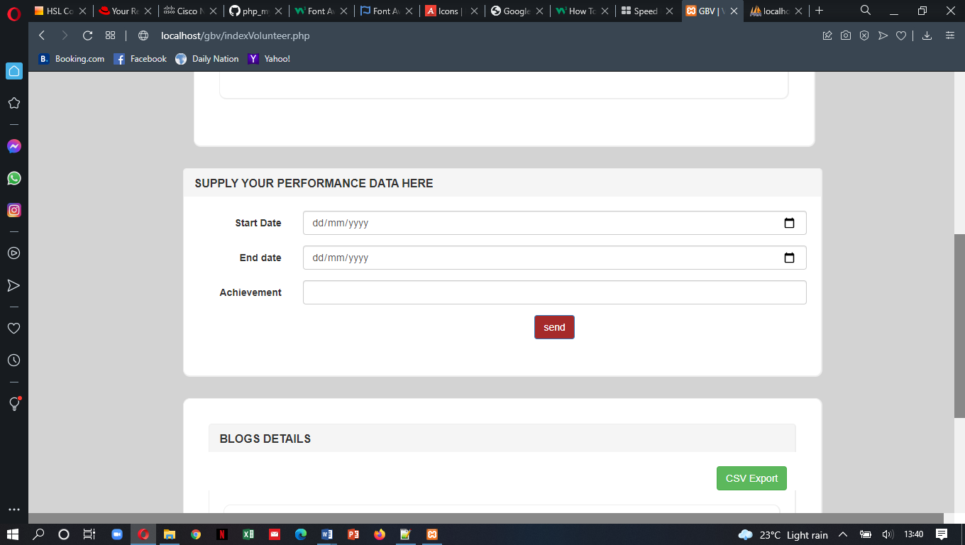

*Figure 7.10: Volunteer Performance input Interface*

Volunteers can also write and view blogs

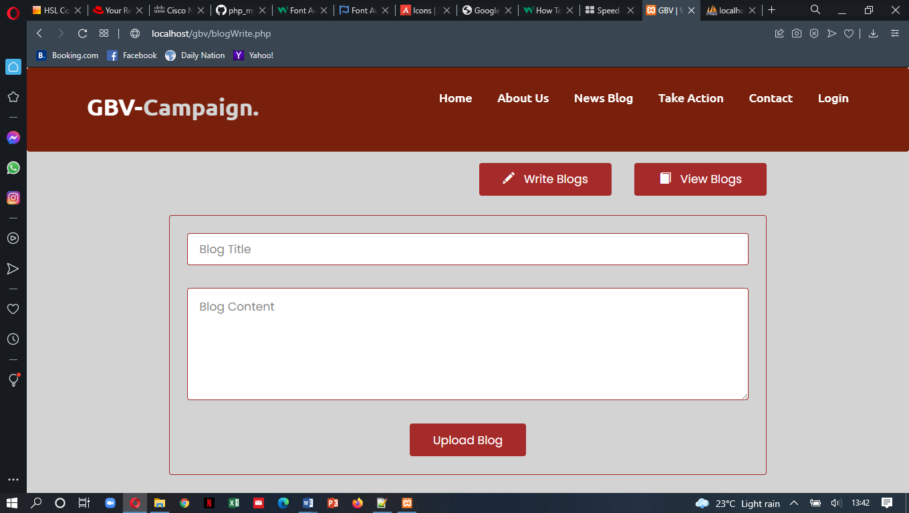

*Figure 7.10: Blog Writing Interface*

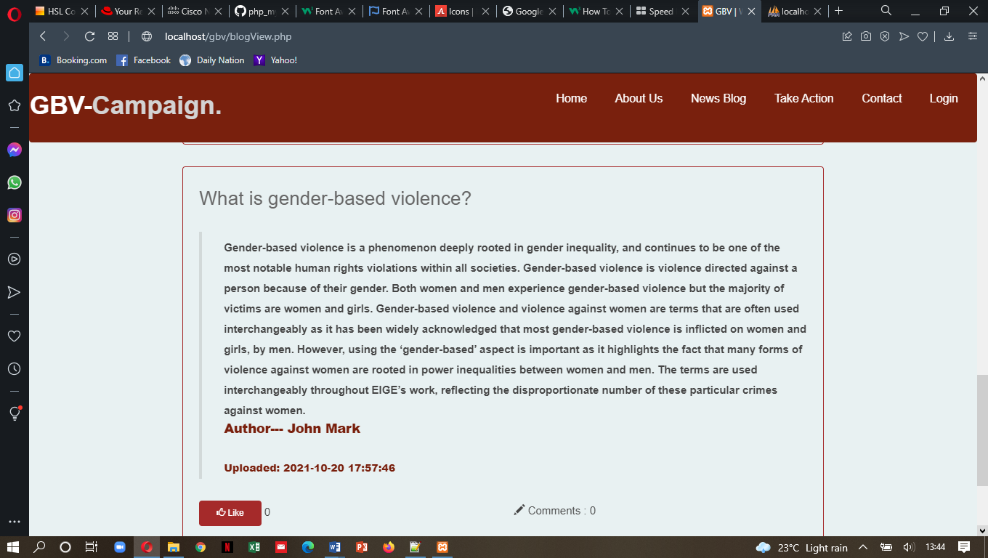

*Figure 7.11: Blog Viewing Interface*

Volunteers can view all the blogs they have uploaded and export the file as well

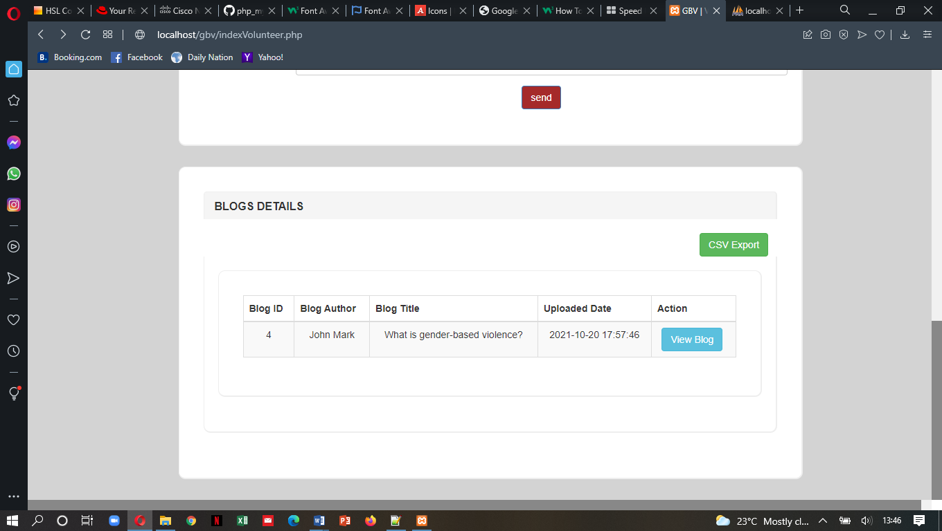

*Figure 7.12: Individual uploaded blogs by users*

When a user logs in as an admin, they are directed to the admin panel

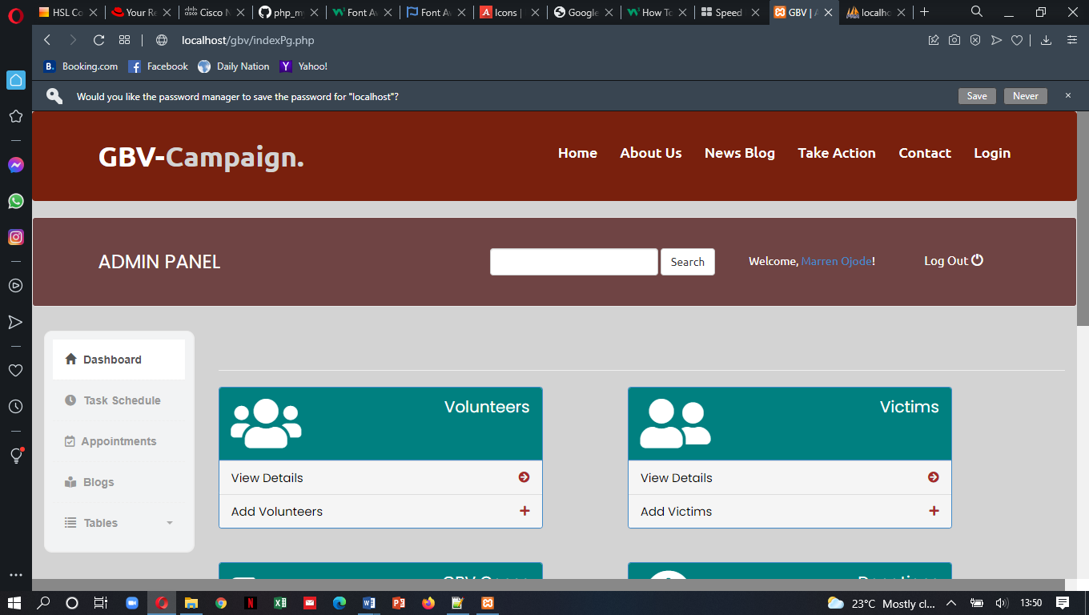

*Figure 7.13: Admin Panel Interface*

The admin can add, view, update, delete and export all the victims registered in the system

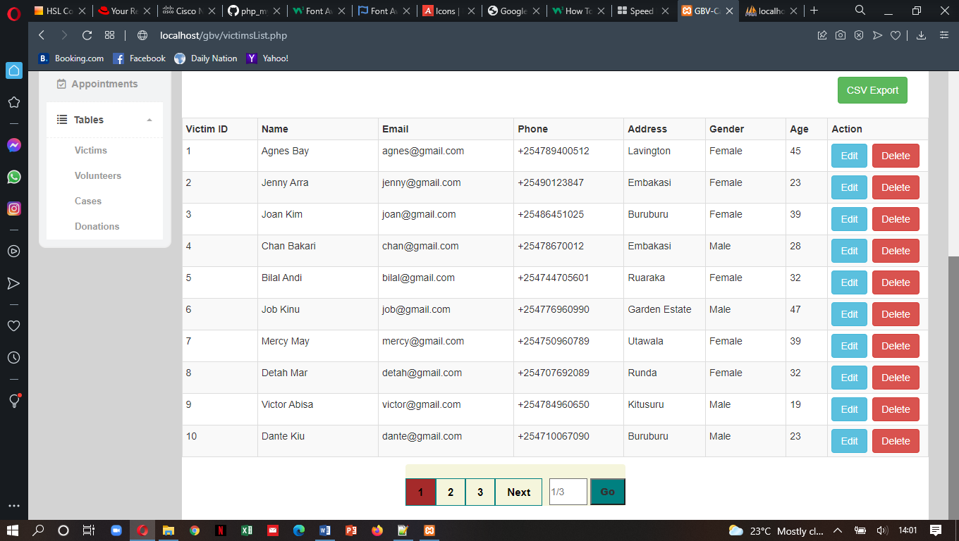

*Figure 7.14: Victim’s List and Admin CRUD Operations*

The admin can add, view, update, delete and export all the volunteers registered in the system

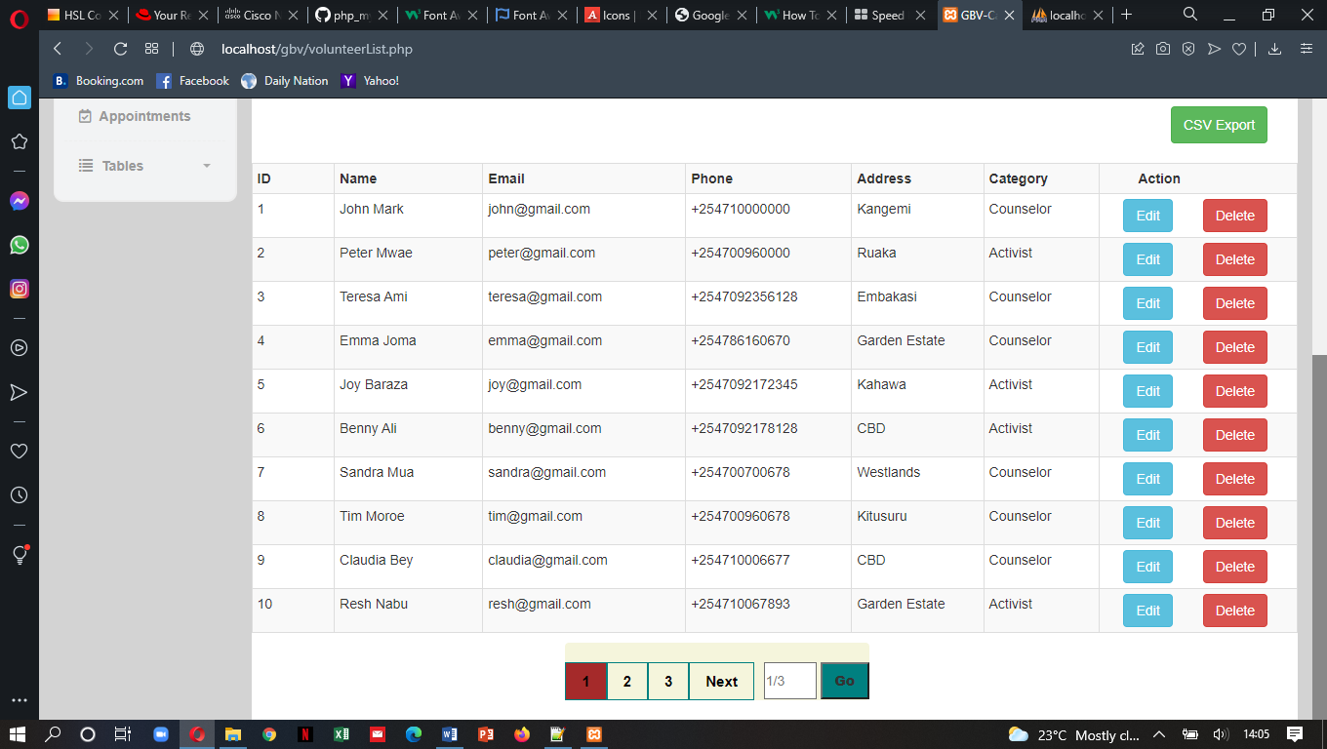

*Figure 7.15: Volunteer’s List and Admin CRUD Operations*

The admin can view and export the donations made by well-wishers.

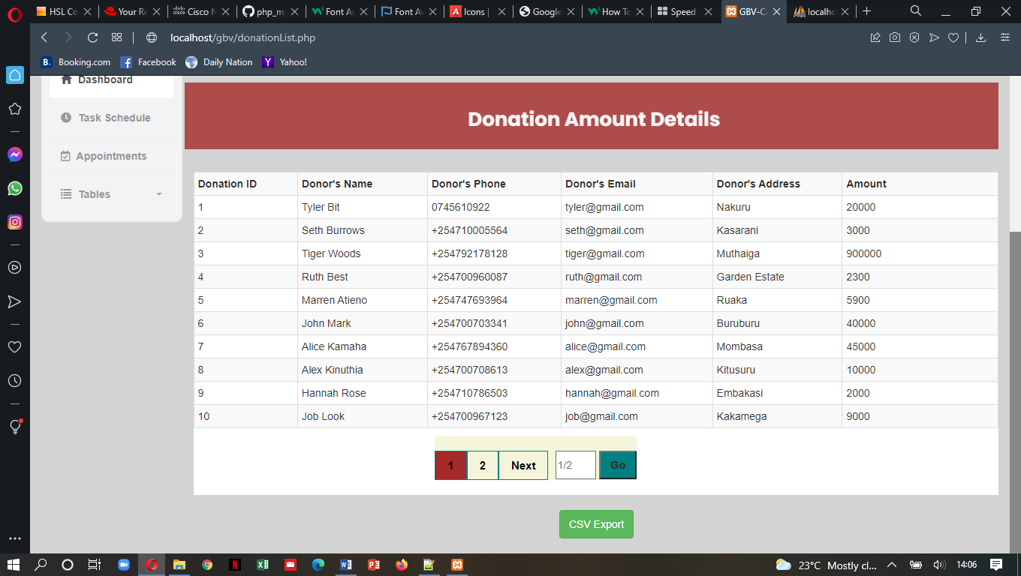

*Figure 7.16: Donation’s List*

The admin can assign volunteers tasks and cases

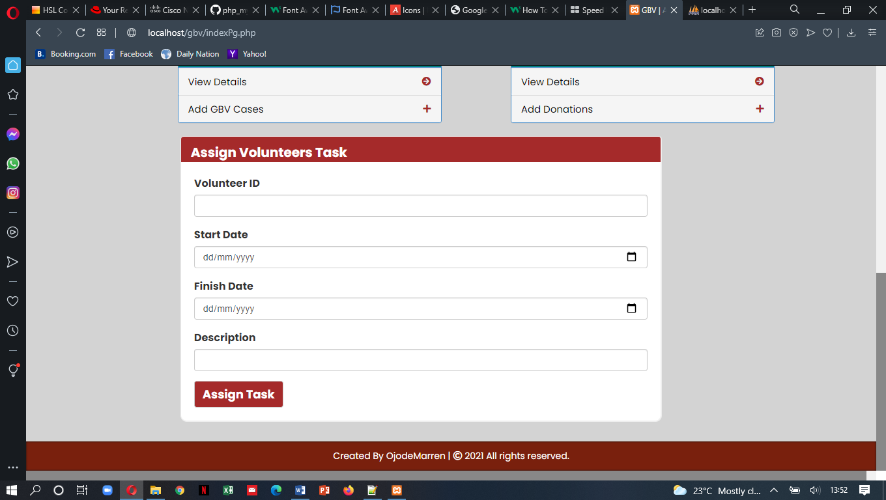

*Figure 7.17: Assigning Tasks Interface*

The admin can view and export the tasks assigned to the volunteers

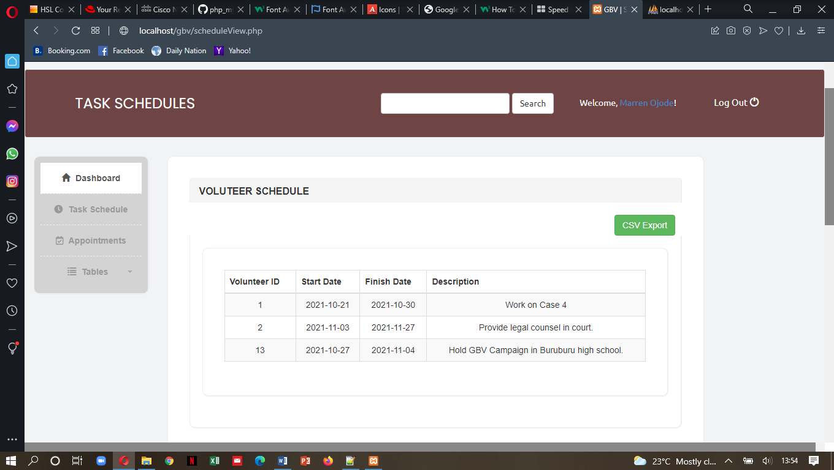

*Figure 7.18: Task Schedule Report*

The admin can also view and export the productivity and progress of the tasks assigned to the volunteers

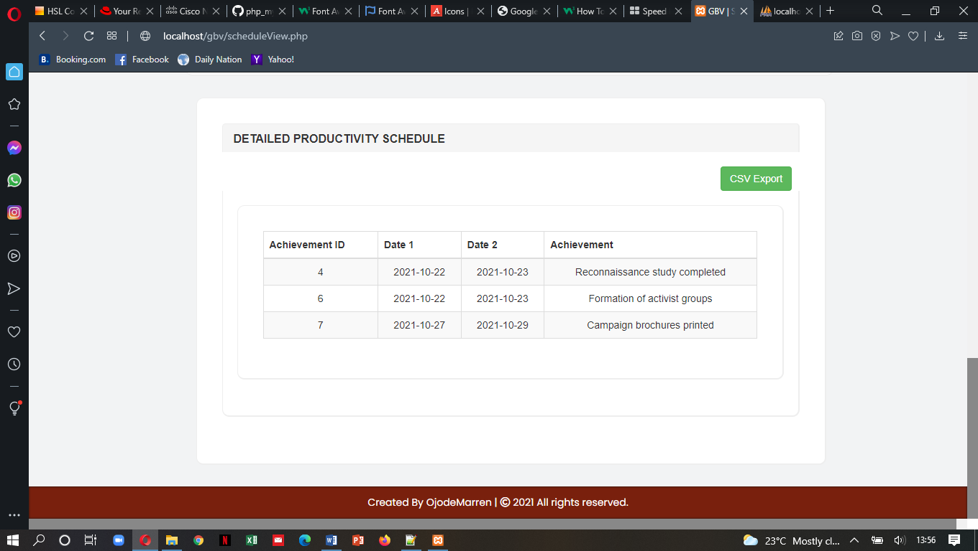

*Figure 7.19: Productivity Schedule Report*

The admin can view and export all the appointments made by victims

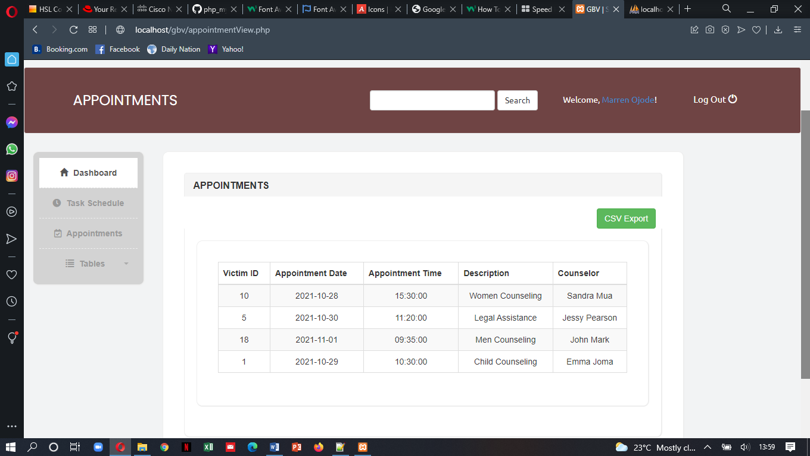

*Figure 7.20: Appointments Report*

The admin can also view and export all the uploaded blogs

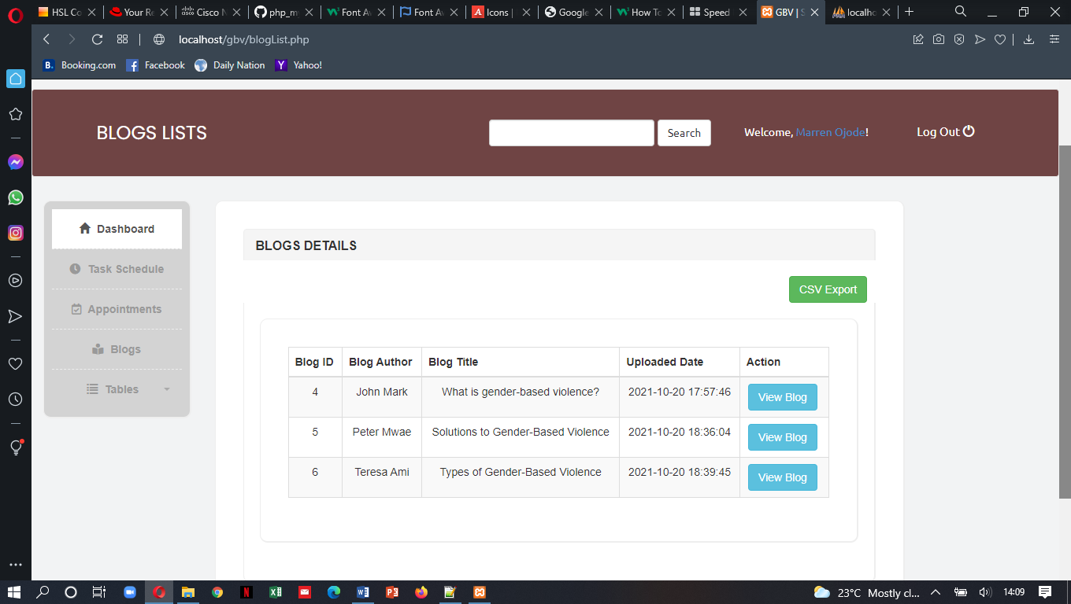

*Figure 7.21: Blog Details Report*

Admin can edit volunteers’ and victims’ details

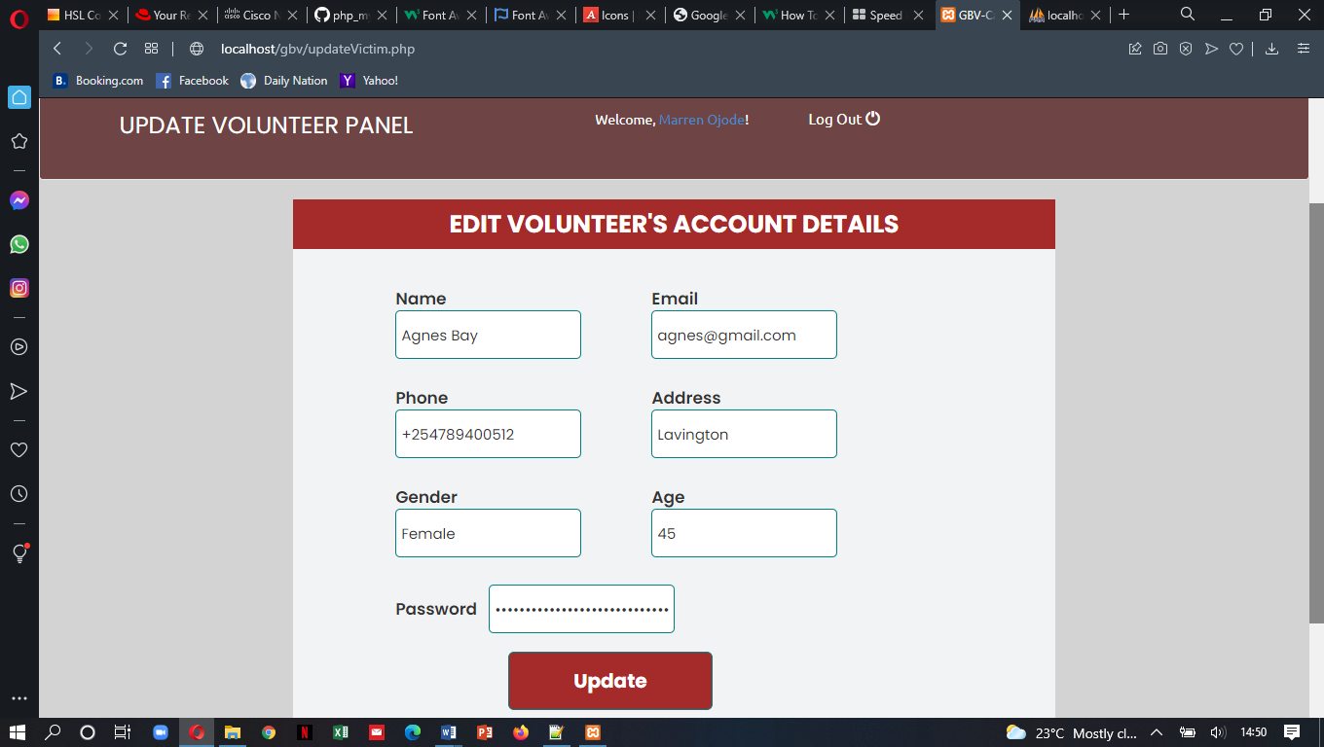

*Figure 7.22: Update Users Form*

## 7.4 Database Management System

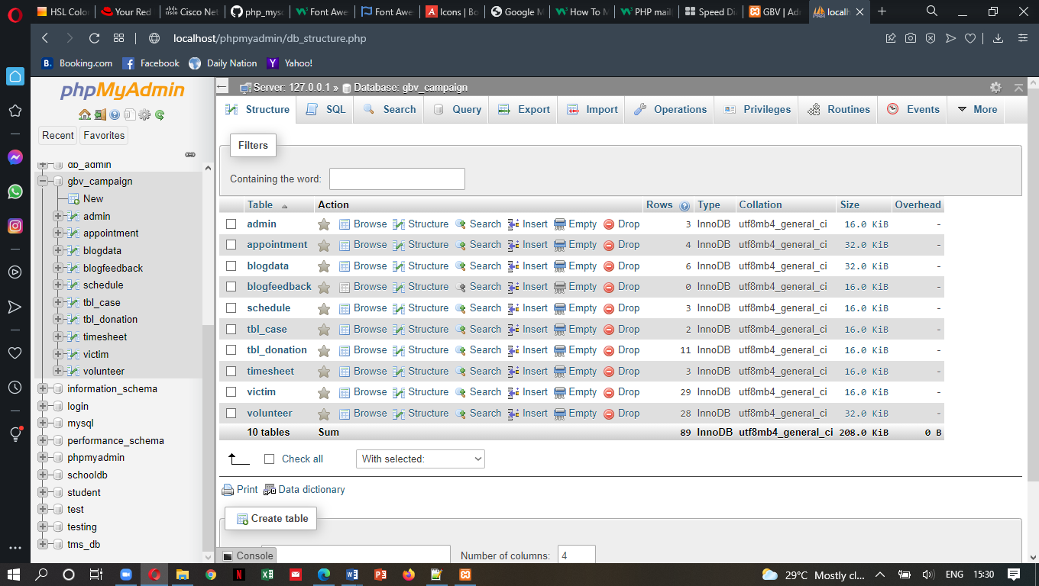

*Figure 7.23: Database Structure*

# **8.0 REFERENCES**

Africa Health Organization. (Jan 14, 2021). *Gender-based-violence fact sheet: South Africa*. Accessed 23 September 2021 from <https://www.aho.org/news/gender-based-violence-f> act-sheet-south-a frica/#:~:text=Gender%20Based%20Violence%20Fact%20Sheet%3A%20South%20Afrc a%2051%25,experienced%20violence%20at%20the%20hands%20of%20a%20partner

*Data Flow Diagram with Examples* - Supermarket App Example. Visual-paradigm.com. (2021). Accessed 3 October 2021, from [https://www.visual-paradigm.com/tutorials/dataflow-](https://www.visual-paradigm.com/tutorials/dataflow-d) diagram/example-supermarket-app.jsp.

Government of Canada. (n.d.). *The Gender-Based Violence Strategy*. Accessed 24 September from [https://women-gender-equality.canada.ca/en/gender-based-violence-knowledge-](https://women-gender-equality.canada.ca/en/gender-based-violence-knowledge-c) centre/gender-based-violence-strategy.html

Guru99. (n.d.).*What is Non-Functional requirement?.*  [Online] Accessed 5 October 2021 from

<https://www.guru99.com/non-functional-requirement-type-example.html#:~:text=KEY%20LEARNING%201%20A%20non-functional%20requirement%20defines%20the,update%20their%20salary%20information.%20...%20More%20items>...

Hu, M. (Dec 2, 2019). *TikTok teams up with UN Women to raise awareness about violence against women in India.* Accesses 24 September 2021 from [https://www.scmp.com/tech/apps-social/article/3040170/tiktok-teams-un-women-raise-](https://www.scmp.com/tech/apps-social/article/3040170/tiktok-teams-un-women-raise-a) awareness-about-violence-against-women

Li, Q., & Chen, Y.-L. (2009). *Data Flow Diagram. Modeling and Analysis of Enterprise and Information Systems,* 85–97. https://doi.org/10.1007/978-3-540-89556-5_4

Mudia, J. (Feb 18, 2020). *WARDC campaign against gender violence: Nigeria.* Accessed 23 September 2021 from [https://www.developmentdiaries.com/2020/02/nigeria-wardc-](https://www.developmentdiaries.com/2020/02/nigeria-wardc-c) campaigns-against-gender-violence/

Mueni, J. (April 22, 2021). *Kenya Records 36 percent spike in GBV cases in 2020 Covid-19 Period.* Accessed 15 September 2021 from https://www.capitalfm.co.ke/news/2021/04/kenya-records-36-per-cent-spike-in-gbv-c ases-in-2020-covid-19-period/

National Crime Research Center. (n.d.).*Gender-based-violence in Kenya*. Accessed 20 September 2021 from  [http://crimeresearch.go.ke/wpcontent/uploads/2018/02/wwwroot_publications_GenderB sed-Violence-in-Kenya.pdf](%09%09http://crimeresearch.go.ke/wpcontent/uploads/2018/02/wwwroot_publications_GenderB%20%09sed-Violence-in-Kenya.pdf)

Rosenblatt, G. B. (2011). *System Analysis and Design*. Boston: Shelly Cashman.

Tutorial point. (n.d.). *Functional Requirements*. Accessed 29 September 2021 from

<https://www.tutorialspoint.com/software_testing_dictionary/functional_requirements.htm>

Tutorial point. (n.d.). *System analysis and design*. Accessed 29 September 2021 from

<https://www.tutorialspoint.com/system_analysis_and_design/system_analysis_and_design_overview.htm>

# **9.0 APPENDIX.**

## 9.1 Questionnaire/Interview schedule

### Section A – Respondents bio data and demographics

1. What is your gender
2. Male
3. Female
4. What is your age bracket?
5. Below 19
6. 20 – 29
7. 30 – 39
8. 40 – 49
9. Above 50
10. Where do you live?
11. Urban [ ]
12. Semi-urban [ ]
13. Rural [ ]
14. What is your level of education?
15. Primary [ ]
16. High [ ]
17. University [ ]
18. In your own understanding, what constitutes Gender-Based Violence?
19. Physical harm inflicted by a man/woman on a woman/man [ ]
20. Sexual assaults on women and children (e.g. rape) [ ]
21. Psychological harm inflicted by a woman/man on a man/woman (fear, shame) [ ]
22. Denial of opportunities and equal rights to women/men [ ]
23. Verbal abuse against women/men [ ]
24. Discrimination against women [ ]
25. Have you EVER or do you know someone who has EVER experience any acts of GBV, past or present?
26. Yes
27. No
28. Which is your most common source of GBV information?
29. Internet sources (e.g. websites)
30. Newspapers
31. TV and Media
32. Books and Journals

### SECTION B – Challenges of existing systems and benefits of the Online GBV Campaign and Awareness System

1. What are some of the challenges with the existing GBV Campaign and Awareness Systems?
2. Complicated and complex system user interfaces [ ]
3. Lack of safe and secure spaces for reporting GBV cases [ ]
4. Limited sources of information that address issues related to gender-based violence [ ]
5. Inaccurate and inconsistent information and data about gender-based violence [ ]
6. Existing systems do not protect my privacy and confidential information [ ]
7. It is expensive to access information using the existing systems [ ]
8. The systems do not provide real-time communication with help providers [ ]
9. The systems do not provide platforms for campaigning against GBV [ ]
10. I expect the following from this Online GBV Campaign and Awareness System
11. Provision of accurate information about gender-based violence [ ]
12. Provision of a safe space where GBV victims can report any act of GBV violence [ ]
13. Provide platforms for activists to campaign against GBV [ ]
14. Enhance easy access to resources and professional help [ ]
15. Provide a simple user-friendly interface for victims and others to obtain information [ ]
16. Improved protection for my private and confidential information [ ]
17. Real-time communication with counselors and other help providers [ ]
18. Low cost of accessing GBV related information [ ]
19. Would recommend this Online GBV Campaign and Awareness System to others?
20. Yes
21. No

## 9.2 Work plan in Grant Chart format

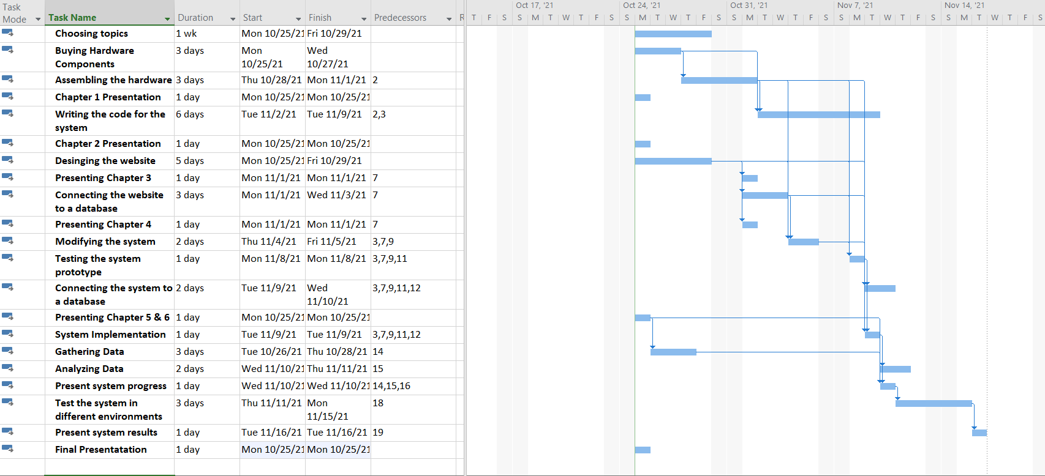

Figure 9‑1 Work plan in Grant Chart format

## 9.3 Project Budget

|  |  |  |  |
| --- | --- | --- | --- |
| **Item** | **Quantity** | **Price Per Item (Kshs)** | **Total** |
| Arduino UNO board | 1 | 1,500 | 1,500 |
| Breadboard | 1 | 100 | 100 |
| Soil Moisture Sensor | 1 | 700 | 700 |
| Water Level Sensor | 1 | 550 | 550 |
| Jump Wires | 11 | 4 | 44 |
| LCD | 1 | 700 | 700 |
| Buzzer | 1 | 100 | 100 |
| LEDs | 2 | 175 | 350 |
| 9V battery | 1 | 250 | 250 |
| Resistor | 4 | 20 | 80 |
| Arduino IDE | 1 | free | 0 |
| **Total** |  |  | **4,374** |

Table 9‑2 Budget